Creating simple dummy rest api

To make static .json file as simple rest api. node js provide pre defined module

Ie json-server

npm install -g json-server

json-server is a pre-defined node js module which help to make static json file as rest api or

dummy rest api or dummy database with rest api

json-server filename.json

On this file using axios we can

store to store the we can use axios.post() method insert query

delete to delete we can use axios.delete() method delete query

update to update we can use axios.put() method update query

retrieve to retrieve we can use axios.get() method. select query

these all operation we can achieve

create-react-app product-rest-api

cd product-rest-api

npm install axios

npm start

DisplayProduct.js get method to retrieve all products

axios.get(“URL”).then().catch(); in get only 1 parameter

AddProduct.js post method to store product info

axios.post(“url”,jsonData).then().catch(); in post 2 parameter 1st url and 2nd json data.

DeleteProduct.js delete method to delete product using id

axios.delete(“url/”+id).then().catch();

UpdateProduct.js put method to update product price using id

axios.put(“url”,jsonData).then().catch();

Component relationship

By default App.js (parent components)

Inside App.js JSX if we use user defined component those component is known as child components.

Component Communication -🡪

1. Parent – Child -🡪 Using props we can pass the value from parent to child.
2. Child – Parent -🡪 Using props with callback functions
3. Child1 – Child2 (Sibling ) Child1 pass the value to parent and parent pass the value to Child2

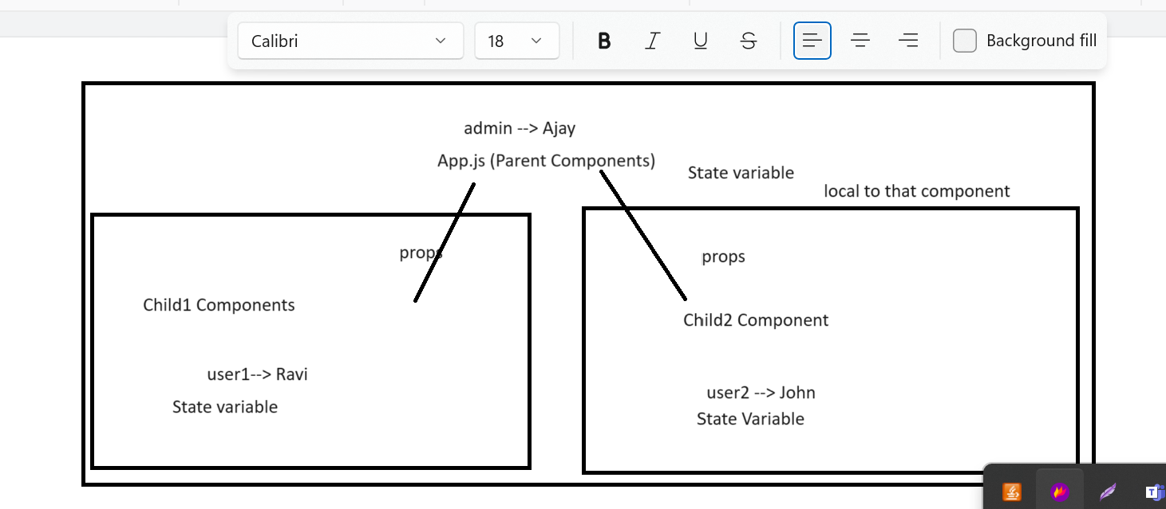

Create-react-app component-communication